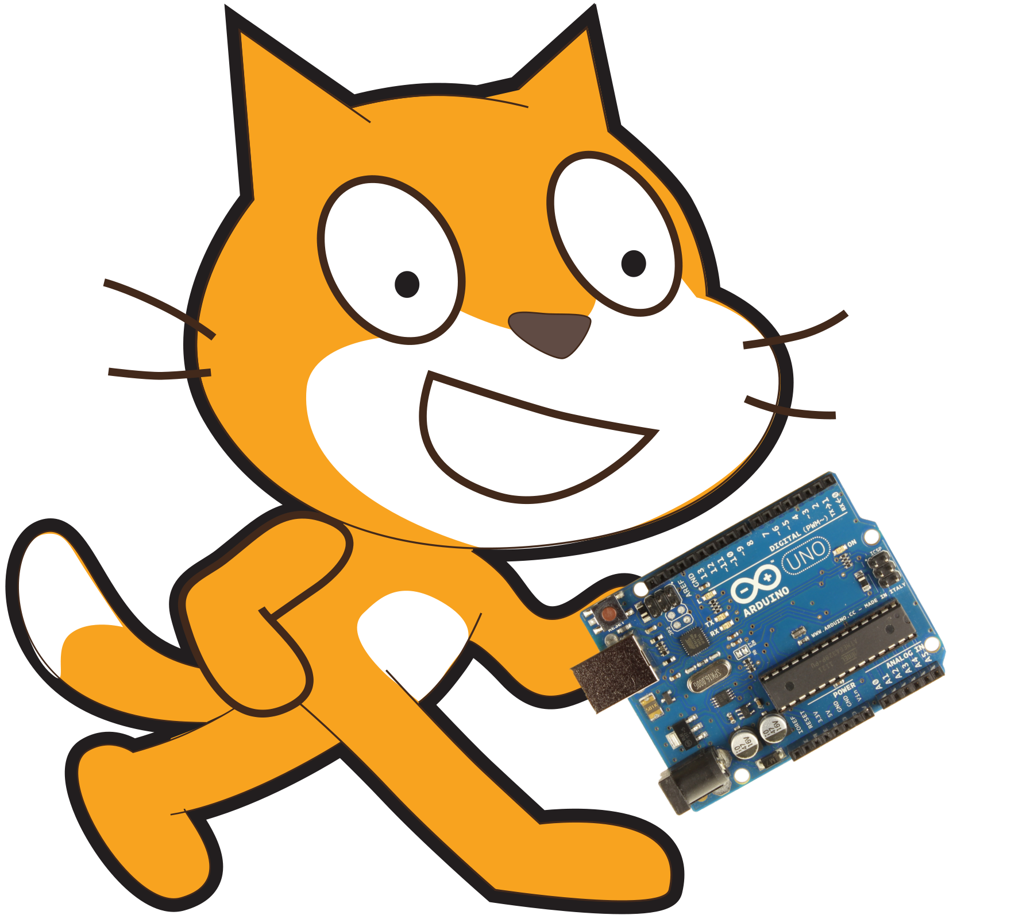
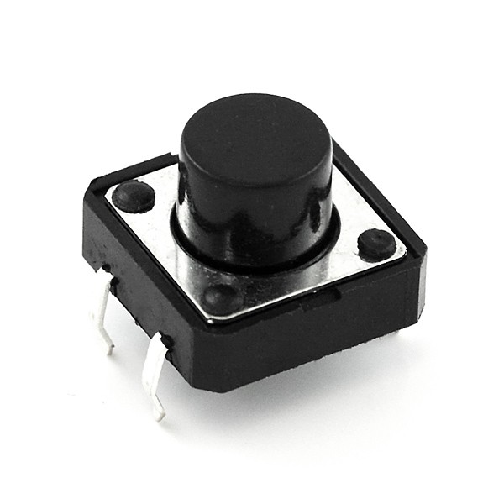
Reading Digital Inputs Using Scratch V2.0
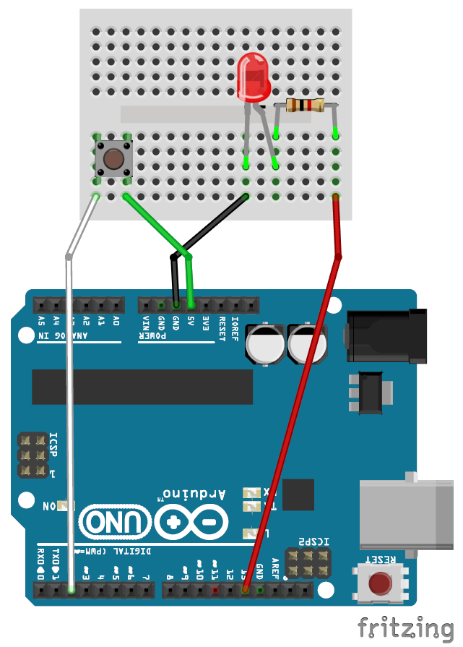
1K ohm Resistors
LED only works if plugged into the circuit the correct way round. The longer leg should
be on the right.

Push Button

Step 1:
Make sure you have your Arduino ready to work with Scratch. You should have done this already by following the steps in the 'SetupYourArduinoForScratch' document.

Step 2:
Create a circuit like the one to the right. It is important to note that there is an LED plugged into digital pin 13 and the switch is plugged into digital pin 2.

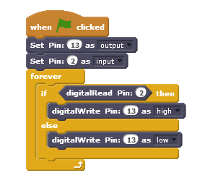

Step 3:
Create a block like the one to the left in scratch. You have already seen the 'Set Pin' and 'digitalWrite' blocks and should understand what they do. The new block here is 'digitalRead'. This block gives a true or false value for the sensor we have connected. So when we press the button it returns true and when not pressed it is false.
Press the green flag in Scratch and see what happens when you press the button.

How does this all work?

We have already discussed how the LED circuit works. We will now discuss how the push button circuit works. When we push the button it connects the two wires it is joined to otherwise the two wires are disconnected. So when we press the button, digital pin 2 receives 5V. When not pressed digital pin 2 receives 0V. digitalRead counts 3V or more as true and 2V or below as false. Hence when we press the push button pin 2 receives 5V and digitalRead is true, and when we release the button pin 2 receives 0V and digitalRead is false.

